LAB MANUAL

Lab Name : Network Programming Lab
Lab Code : 4CS4-23
Branch : Computer Science Engineering
Year : 2nd Year


Jaipur Engineering College and Research Center, Jaipur
Department of Computer Science Engineering
(Rajasthan Technical University, KOTA)

INDEX

S.NO | CONTENTS | CO | PAGE NO.
1 | VISION/MISION
2. | PEOs
3. | PO’s
4. | CO’s
5. | MAPPING OF CO & PO
6. | SYLLABUS
7. | TOPIC BEYOND SYLLABUS COVERAGE
8. | LIST OF EXPERIMENTS (RTU SYLLABUS)

JAIPUR ENGINEERING COLLEGE AND RESEARCH CENTER
Department of Computer Science & Engineering
Branch: Computer Science & Engineering Semester: 4th
Course Name: NP Lab Code: 4CS2-23
External Marks: 45 Practical hrs:3 hr/week
Internal Marks: 30 Total Marks: 75
- VISION & MISSION

Vision of the Department

To become renowned Centre of excellence in computer science and engineering and make competent engineers & professionals with high ethical values prepared for lifelong learning.

Mission of the Department

M1- To impart outcome based education for emerging technologies in the field of computer science and engineering.

M2 - To provide opportunities for interaction between academia and industry.

M3 - To provide platform for lifelong learning by accepting the change in technologies

M4 - To develop aptitude of fulfilling social responsibilities.

- PEO
1. To provide students with the fundamentals of Engineering Sciences with more emphasis in Computer Science &Engineering by way of analyzing and exploiting engineering challenges.
2. To train students with good scientific and engineering knowledge so as to comprehend, analyze, design, and create novel products and solutions for the real life problems.
3. To inculcate professional and ethical attitude, effective communication skills, teamwork skills, multidisciplinary approach, entrepreneurial thinking and an ability to relate engineering issues with social issues.
4. To provide students with an academic environment aware of excellence, leadership, written ethical codes and guidelines, and the self motivated life-long learning needed for a successful professional career.
5. To prepare students to excel in Industry and Higher education by Educating Students along with High moral values and Knowledge

- PROGRAM OUTCOMES
- Engineering knowledge: Apply the knowledge of mathematics, science, engineering fundamentals, and Computer Science & Engineering specialization to the solution of complex Computer Science & Engineering problems.
- Problem analysis: Identify, formulate, research literature, and analyze complex computer Computer Science & Engineering problems reaching substantiated conclusions using first principles of mathematics, natural sciences, and engineering sciences.
- Design/development of solutions: Design solutions for complex Computer Science& Engineeringproblems and design system components or processes that meet the specified needs with appropriate consideration for the public health and safety, and the cultural, societal, and environmental considerations.
- Conduct investigations of complex problems: Use research-based knowledge and research methods including design of Computer Science & Engineering experiments, analysis and interpretation of data, and synthesis of the information to provide valid conclusions.
- Modern tool usage: Create, select, and apply appropriate techniques, resources, and modern Computer Science& Engineering and IT tools including prediction and modeling to complex computer science engineering activities with an understanding of the limitations.
- The engineer and society: Apply reasoning informed by the contextual knowledge to assess societal, health, safety, legal and cultural issues and the consequent responsibilities relevant to the professional Computer Science & Engineering practice.
- Environment and sustainability: Understand the impact of the professional Computer Science & Engineering solutions in societal and environmental contexts, and demonstrate the knowledge of, and need for sustainable development.
- Ethics: Apply ethical principles and commit to professional ethics and responsibilities and norms of the Computer Science & Engineering practice.
- Individual and team work: Function effectively as an individual, and as a member or leader in diverse teams, and in multidisciplinary settings in Computer Science & Engineering.
- Communication: Communicate effectively on complex Computer Science & Engineering activities with the engineering community and with society at large, such as, being able to comprehend and write effective reports and design documentation, make effective presentations, and give and receive clear instructions.
- Project management and finance: Demonstrate knowledge and understanding of the Computer Science & Engineering and management principles and apply these to one’s own work, as a member and leader in a team, to manage projects and in multidisciplinary environments.
- Life-long learning: Recognize the need for, and have the preparation and ability to engage in independent and life-long learning in the broadest context of Computer Science& Engineering change.
INSTRUCTIONS OF LAB

DO’s
- Please switch off the Mobile/Cell phone before entering Lab.
- Enter the Lab with complete source code and data.
- Check whether all peripheral are available at your desktop before proceeding for program.
- Intimate the lab In charge whenever you are incompatible in using the system or in case software get corrupted/ infected by virus.
- Arrange all the peripheral and seats before leaving the lab.
- Properly shutdown the system before leaving the lab.
- Keep the bag outside in the racks.
- Enter the lab on time and leave at proper time.
- Maintain the decorum of the lab.
- Utilize lab hours in the corresponding experiment.
- Get your Cd / Pendrive checked by lab In charge before using it in the lab.

DON’TS
- No one is allowed to bring storage devices like Pan Drive /Floppy etc. in the lab.
- Don’t mishandle the system.
- Don’t leave the system on standing for long
- Don’t bring any external material in the lab.
- Don’t make noise in the lab.
- Don’t bring the mobile in the lab. If extremely necessary then keep ringers off.
- Don’t enter in the lab without permission of lab Incharge.
- Don’t litter in the lab.
- Don’t delete or make any modification in system files.
- Don’t carry any lab equipments outside the lab.

INSTRUCTIONS FOR STUDENT
BEFORE ENTERING IN THE LAB

- All the students are supposed to prepare the theory regarding the next program.
- Students are supposed to bring the practical file and the lab copy.
- Assignment given in previous labs should be written in the practical file.
- Print out of diagram should be pasted in the lab file.
- Any student not following these instructions will be denied entry in the lab.

WHILE WORKING IN THE LAB
- Adhere to experimental schedule as instructed by the lab incharge.
- Get the previously executed program signed by the instructor.
- Get the output of the current program checked by the instructor in the lab copy.
- Each student should work on his/her assigned computer at each turn of the lab.
- Take responsibility of valuable accessories.
- Concentrate on the assigned practical and do not play games.
- If anyone caught red handed carrying any equipment of the lab, then he will have to face serious consequences.

Objective 1: Study of Different Type of LAN& Network Equipments

A local area network, or LAN, consists of a computer network at a single site, typically an individual office building. A LAN is very useful for sharing resources, such as data storage and printers. LANs can be built with relatively inexpensive hardware, such as hubs, network adapters and Ethernet cables.
The smallest LAN may only use two computers, while larger LANs can accommodate thousands of computers. A LAN typically relies mostly on wired connections for increased speed and security, but wireless connections can also be part of a LAN. High speed and relatively low cost are the defining characteristics of LANs.
LANs are typically used for single sites where people need to share resources among themselves but not with the rest of the outside world. Think of an office building where everybody should be able to access files on a central server or be able to print a document to one or more central printers. Those tasks should be easy for everybody working in the same office, but you would not want somebody just walking outside to be able to send a document to the printer from their cell phone! If a local area network, or LAN, is entirely wireless, it is referred to as a wireless local area network, or WLAN.

Types of Local-Area Networks (LANs)
There are many different types of LANs, with Ethernets being the most common for PCs. Most Apple Macintosh networks are based on Apple's AppleTalk network system, which is built into Macintosh computers. The following characteristics differentiate one LAN from another:
- Topology: The geometric arrangement of devices on the network. For example, devices can be arranged in a ring or in a straight line.
- Protocols: The rules and encoding specifications for sending data. The protocols also determine whether the network uses a peer-to-peer or client/server architecture.
- Media: Devices can be connected by twisted-pair wire, coaxial cables, or fiber optic cables. Some networks do without connecting media altogether, communicating instead via radio waves.

Deploying a Wireless LAN
Wireless networks are relatively easy to implement these days, especially when compared to the prospect of having to route wires when deploying a new wired network or overhauling an existing one. The first step in planning a wireless LAN deployment should be to decide on your wireless networking technology standard. Keep in mind that the standard you need to accommodate your network access points and routers as well as the entire collection of wireless network interface cards (NICs) for your computers and other network resources.

Different networking devices:

Network Hub:
Network Hub is a networking device which is used to connect multiple network hosts. A network hub is also used to do data transfer. The data is transferred in terms of packets on a computer network. So when a host sends a data packet to a network hub, the hub copies the data packet to all of its ports connected to. Like this, all the ports know about the data and the port for whom the packet is intended, claims the packet.
However, because of its working mechanism, a hub is not so secure and safe. Moreover, copying the data packets on all the interfaces or ports makes it slower and more congested which led to the use of network switch.

Network Switch:
Like a hub, a switch also works at the layer of LAN (Local Area Network) but you can say that a switch is more intelligent than a hub. While hub just does the work of data forwarding, a switch does 'filter and forwarding' which is a more intelligent way of dealing with the data packets.
So, when a packet is received at one of the interfaces of the switch, it filters the packet and sends only to the interface of the intended receiver. For this purpose, a switch also maintains a CAM (Content Addressable Memory) table and has its own system configuration and memory. CAM table is also called as forwarding table or forwarding information base (FIB).

Modem:
A Modem is somewhat a more interesting network device in our daily life. So if you have noticed around, you get an internet connection through a wire (there are different types of wires) to your house. This wire is used to carry our internet data outside to the internet world.
However, our computer generates binary data or digital data in forms of 1s and 0s and on the other hand, a wire carries an analog signal and that's where a modem comes in.
A modem stands for (Modulator+Demodulator). That means it modulates and demodulates the signal between the digital data of a computer and the analog signal of a telephone line.

Network Router:
A router is a network device which is responsible for routing traffic from one to another network. These two networks could be a private company network to a public network. You can think of a router as a traffic police who directs different network traffic to different directions.

Bridge:
If a router connects two different types of networks, then a bridge connects two subnetworks as a part of the same network. You can think of two different labs or two different floors connected by a bridge.

Repeater:
A repeater is an electronic device that amplifies the signal it receives. In other terms, you can think of repeater as a device which receives a signal and retransmits it at a higher level or higher power so that the signal can cover longer distances.
For example, inside a college campus, the hostels might be far away from the main college where the ISP line comes in. If the college authority wants to pull a wire in between the hostels and main campus, they will have to use repeaters if the distance is much because different types of cables have limitations in terms of the distances they can carry the data for.
Objective2: Study and Verification of standard Network topologies i.e. Star, Bus, Ring etc.
A network topology is the arrangement of a network, including its nodes and connecting lines. There are two ways of defining network geometry: the physical topology and the logical (or signal)topology.

BUS Topology
Bus topology is a network type in which every computer and network device is connected to single cable. When it has exactly two endpoints, then it is called Linear Bus topology.
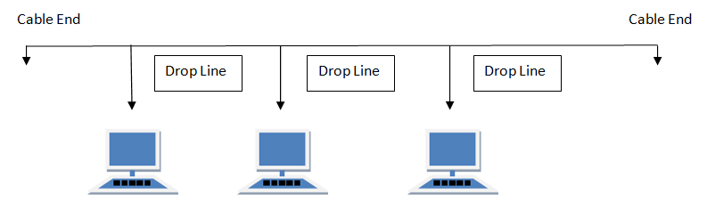

Features of Bus Topology
- It transmits data only in one direction.
- Every device is connected to a single cable

Advantages of Bus Topology
- It is cost effective.
- Cable required is least compared to other network topology.
- Used in small networks.
- It is easy to understand.
- Easy to expand joining two cables together.

Disadvantages of Bus Topology
- Cables fails then whole network fails.
- If network traffic is heavy or nodes are more the performance of the network decreases.
- Cable has a limited length.
- It is slower than the ring topology.

RING Topology
It is called ring topology because it forms a ring as each computer is connected to another computer, with the last one connected to the first. Exactly two neighbours for each device.
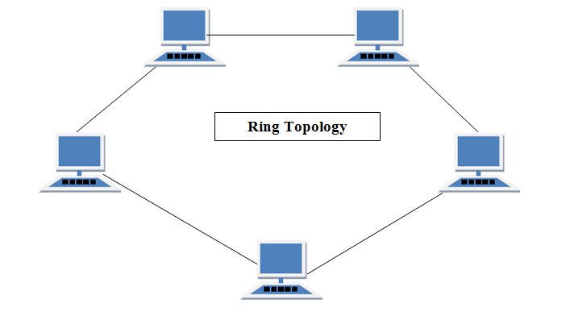

Features of Ring Topology
- A number of repeaters are used for Ring topology with large number of nodes, because if someone wants to send some data to the last node in the ring topology with 100 nodes, then the data will have to pass through 99 nodes to reach the 100th node. Hence to prevent data loss repeaters are used in the network.
- The transmission is unidirectional, but it can be made bidirectional by having 2 connections between each Network Node, it is called Dual Ring Topology.
- In Dual Ring Topology, two ring networks are formed, and data flow is in opposite direction in them. Also, if one ring fails, the second ring can act as a backup, to keep the network up.
- Data is transferred in a sequential manner that is bit by bit. Data transmitted, has to pass through each node of the network, till the destination node.

Advantages of Ring Topology
- Transmitting network is not affected by high traffic or by adding more nodes, as only the nodes having tokens can transmit data.
- Cheap to install and expand

Disadvantages of Ring Topology
- Troubleshooting is difficult in ring topology.
- Adding or deleting the computers disturbs the network activity.
- Failure of one computer disturbs the whole network.

STAR Topology
In this type of topology all the computers are connected to a single hub through a cable. This hub is the central node and all others nodes are connected to the central node.
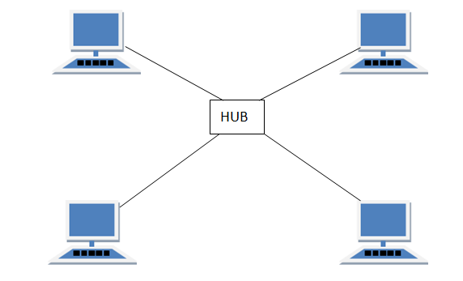

Features of Star Topology
- Every node has its own dedicated connection to the hub.
- Hub acts as a repeater for data flow.
- Can be used with twisted pair, Optical Fibre or coaxial cable.

Advantages of Star Topology
- Fast performance with few nodes and low network traffic.
- Hub can be upgraded easily.
- Easy to troubleshoot.
- Easy to setup and modify.
- Only that node is affected which has failed, rest of the nodes can work smoothly.

Disadvantages of Star Topology
- Cost of installation is high.
- Expensive to use.
- If the hub fails then the whole network is stopped because all the nodes depend on the hub.
- Performance is based on the hub that is it depends on its capacity

MESH Topology
It is a point-to-point connection to other nodes or devices. All the network nodes are connected to each other. Mesh has n(n-1)/2 physical channels to link n devices.
There are two techniques to transmit data over the Mesh topology, they are :
- Routing
- Flooding

MESH Topology: Routing
In routing, the nodes have a routing logic, as per the network requirements. Like routing logic to direct the data to reach the destination using the shortest distance. Or, routing logic which has information about the broken links, and it avoids those node etc. We can even have routing logic, to re-configure the failed nodes.

MESH Topology: Flooding
In flooding, the same data is transmitted to all the network nodes, hence no routing logic is required. The network is robust, and the its very unlikely to lose the data. But it leads to unwanted load over the network.
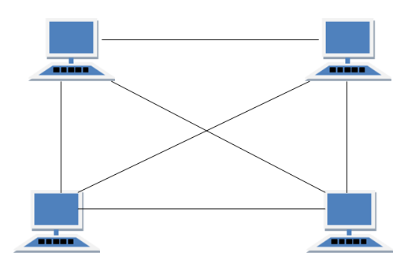

Types of Mesh Topology
- Partial Mesh Topology : In this topology some of the systems are connected in the same fashion as mesh topology but some devices are only connected to two or three devices.
- Full Mesh Topology : Each and every nodes or devices are connected to each other.

Features of Mesh Topology
- Fully connected.
- Robust.
- Not flexible.

Advantages of Mesh Topology
- Each connection can carry its own data load.
- It is robust.
- Fault is diagnosed easily.
- Provides security and privacy.

Disadvantages of Mesh Topology
- Installation and configuration is difficult.
- Cabling cost is more.
- Bulk wiring is required.

TREE Topology
It has a root node and all other nodes are connected to it forming a hierarchy. It is also called hierarchical topology. It should at least have three levels to the hierarchy.
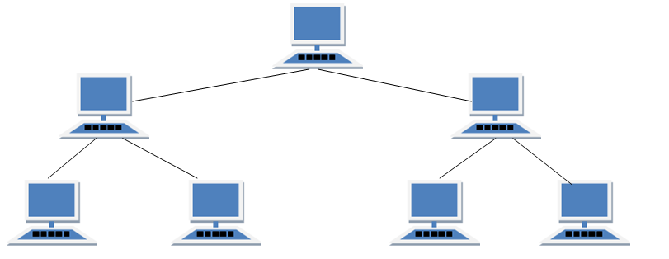

Features of Tree Topology
- Ideal if workstations are located in groups.
- Used in Wide Area Network.

Advantages of Tree Topology
- Extension of bus and star topologies.
- Expansion of nodes is possible and easy.
- Easily managed and maintained.
- Error detection is easily done.

Disadvantages of Tree Topology
- Heavily cabled.
- Costly.
- If more nodes are added maintenance is difficult.
- Central hub fails, network fails.

HYBRID Topology
It is two different types of topologies which is a mixture of two or more topologies. For example if in an office in one department ring topology is used and in another star topology is used, connecting these topologies will result in Hybrid Topology (ring topology and star topology).
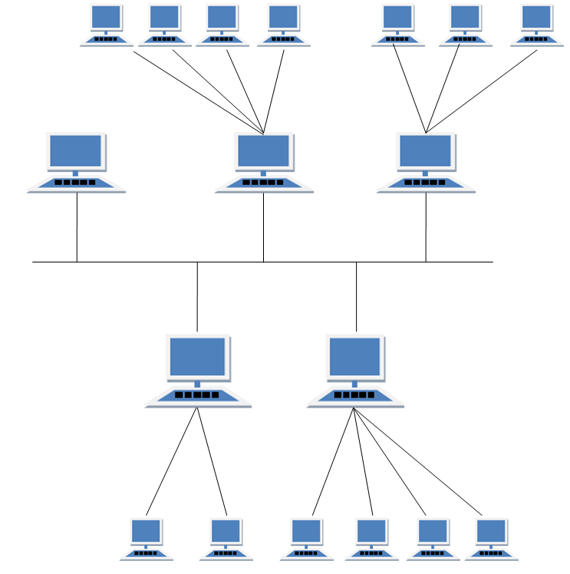

Features of Hybrid Topology
- It is a combination of two or topologies
- Inherits the advantages and disadvantages of the topologies included

Advantages of Hybrid Topology
- Reliable as Error detecting and trouble shooting is easy.
- Effective.
- Scalable as size can be increased easily.
- Flexible.

Disadvantages of Hybrid Topology
- Complex in design.
- Costly.
Objective 3: LAN installations and Configurations
- Take the computer for which you are making server, insert the second LAN in that computer.
- Connect your internet connection into the first LAN (inbuilt) on that computer.
- Enter the IP address which you got from your ISP and check whether you can able to use internet on that system.
- Now make sure that the second LAN is detected and is showing Unplugged.
- Open properties of the first LAN (inbuilt LAN) and then go to "Advanced" option which is available on the top, then check both the boxes and say ok. and close everything.
- Now take an Internet cable which is crimped on both the sides with same colors of wires.
- Connect one end to the second LAN and the other end to the switch.
- Now open your second LAN properties and go to the TCP/IP properties and there enter IP address as (192.168.0.1) or anything you wish Subnet Mask (255.255.255.0) and the gateway as (192.168.0.1).
NOTE :- THE GATEWAY SHOULD BE SAME AS THE IP ADDRESS ONLY FOR THE SERVER.
- Now open click on the switch and you will get a notification on your server saying that "Local Area Connection 2" is connected.
- Now take an another Internet cable and one end of that cable should be in any one port of the Switch and the other should be in the second computer.
- Now you will get a notification that you are connected to internet, open the LAN properties and enter the IP address as (192.168.0.2) subnet mask and gateway should be same as server.
- You will now be able to browse Internet on that particular system now.
- Do the same with the rest of the systems.
NOTE :- THE IP ADDRESSES SHOULD NOT BE USED SAME FOR TWO SYSTEMS. SO BETTER GO WITH 192.168.0.1 (FOR SERVER) 192.168.0.2 (1ST CLIENT) 192.168.0.3(SECOND CLIENT) AND SO ON.......BUT THE SUBNET MASK AND GATEWAYS SHOULD BE SAME FOR ALL THE CLIENT AND SERVER SYSTEM.

Objection 4: Write a program to implement various types of error correcting techniques
Hamming code is a popular error detection and error correction method in data communication. Hamming code can only detect 2 bit error and correct a single bit error which means it is unable to correct burst errors if may occur while transmission of data.
Hamming code uses redundant bits (extra bits) which are calculated according to the below formula:-
2^{r} ≥ m+r+1
Where r is the number of redundant bits required and m is the number of data bits.
R is calculated by putting r = 1, 2, 3 … until the above equation becomes true.
R1 bit is appended at position 2⁰
R2 bit is appended at position 2¹
R3 bit is appended at position 2² and so on.
These redundant bits are then added to the original data for the calculation of error at receiver’s end.
At receiver’s end with the help of even parity (generally) the erroneous bit position is identified and since data is in binary we take complement of the erroneous bit position to correct received data.
Respective index parity is calculated for r1, r2, r3, r4 and so on.
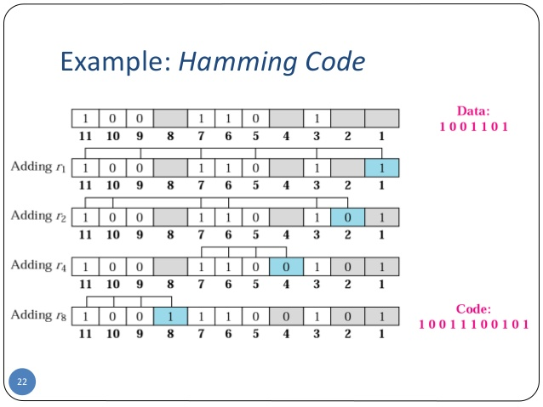

Advantages of Hamming Code
- Easy to encode and decode data at both sender and receiver end.
- Easy to implement.

Disadvantages of Hamming Code
- Cannot correct burst errors.
- Redundant bits are also sent with the data therefore it requires more bandwidth to send the data.

Program for Hamming Code in C

1  2  3  4  5  6  7  8  9  10  11  12  13  14  15  16  17  18  19  20  21  22  23  24  25  26  27  28  29  30  31  32  33  34  35  36  37  38  39  40  41  42  43  44  45  46  47  48  49  50  51  52  53  54  55  56  57 | #include<stdio.h>  void main() {  int data[10];  int dataatrec[10],c,c1,c2,c3,i;  printf("Enter 4 bits of data one by one\n");  scanf("%d",&data[0]);  scanf("%d",&data[1]);  scanf("%d",&data[2]);  scanf("%d",&data[4]);  //Calculation of even parity  data[6]=data[0]^data[2]^data[4];  data[5]=data[0]^data[1]^data[4];  data[3]=data[0]^data[1]^data[2];  printf("\nEncoded data is\n");  for(i=0;i<7;i++)  printf("%d",data[i]);  printf("\n\nEnter received data bits one by one\n");  for(i=0;i<7;i++)  scanf("%d",&dataatrec[i]);  c1=dataatrec[6]^dataatrec[4]^dataatrec[2]^dataatrec[0];  c2=dataatrec[5]^dataatrec[4]^dataatrec[1]^dataatrec[0];  c3=dataatrec[3]^dataatrec[2]^dataatrec[1]^dataatrec[0];  c=c3*4+c2*2+c1 ;  if(c==0) {  printf("\nNo error while transmission of data\n");  }  else {  printf("\nError on position %d",c);  printf("\nData sent : ");  for(i=0;i<7;i++)  printf("%d",data[i]);  printf("\nData received : ");  for(i=0;i<7;i++)  printf("%d",dataatrec[i]);  printf("\nCorrect message is\n");  //if errorneous bit is 0 we complement it else vice versa  if(dataatrec[7-c]==0)  dataatrec[7-c]=1;  else  dataatrec[7-c]=0;  for (i=0;i<7;i++) {  printf("%d",dataatrec[i]);  }  }  }

Program for Hamming Code in C++

1  2  3  4  5  6  7  8  9  10  11  12  13  14  15  16  17  18  19  20  21  22  23  24  25  26  27  28  29  30  31  32  33  34  35  36  37  38  39  40  41  42  43  44  45  46  47  48  49  50  51  52  53  54  55  56  57  58  59  60 | #include<iostream>  using namespace std;  int main() {  int data[10];  int dataatrec[10],c,c1,c2,c3,i;  cout<<"Enter 4 bits of data one by one\n";  cin>>data[0];  cin>>data[1];  cin>>data[2];  cin>>data[4];  //Calculation of even parity  data[6]=data[0]^data[2]^data[4];  data[5]=data[0]^data[1]^data[4];  data[3]=data[0]^data[1]^data[2];  cout<<"\nEncoded data is\n";  for(i=0;i<7;i++)  cout<<data[i];  cout<<"\n\nEnter received data bits one by one\n";  for(i=0;i<7;i++)  cin>>dataatrec[i];  c1=dataatrec[6]^dataatrec[4]^dataatrec[2]^dataatrec[0];  c2=dataatrec[5]^dataatrec[4]^dataatrec[1]^dataatrec[0];  c3=dataatrec[3]^dataatrec[2]^dataatrec[1]^dataatrec[0];  c=c3*4+c2*2+c1 ;  if(c==0) {  cout<<"\nNo error while transmission of data\n";  }  else {  cout<<"\nError on position "<<c;  cout<<"\nData sent : ";  for(i=0;i<7;i++)  cout<<data[i];  cout<<"\nData received : ";  for(i=0;i<7;i++)  cout<<dataatrec[i];  cout<<"\nCorrect message is\n";  //if errorneous bit is 0 we complement it else vice versa  if(dataatrec[7-c]==0)  dataatrec[7-c]=1;  else  dataatrec[7-c]=0;  for (i=0;i<7;i++) {  cout<<dataatrec[i];  }  }  return 0;  }
Output
Enter 4 bits of data one by one
1
0
1
0
Encoded data is
1010010
Enter received data bits one by one
1
0
1
0
0
1
0
Objective 5: Write a program to implement various types of framing methods
Security and Error detection are the most prominent features that are to be provided by any application which transfers data from one end to the other end. One of such a mechanism in tracking errors which may add up to the original data during transfer is known as Stuffing. It is of two types namely Bit Stuffing and the other Character Stuffing. Coming to the Bit Stuffing, 01111110 is appended within the original data while transfer of it. The following program describes how it is stuffed at the sender end and de-stuffed at the receiver end.
#include
main()
{
int a[15];
int i,j,k,n,c=0,pos=0;
clrscr();
printf("\n Enter the number of bits");
scanf("%d",&n);
printf("\n Enter the bits");
for(i=0;i scanf("%d",&a[i]);
for(i=0;i {
if(a[i]==1)
{
c++;
if(c==5)
{
pos=i+1;
c=0;
for(j=n;j>=pos;j--)
{
k=j+1;
a[k]=a[j];
}
a[pos]=0;
n=n+1;
}
}
else
c=0;
}
printf("\n DATA AFTER STUFFING \n");
printf(" 01111110 ");
for(i=0;i {
printf("%d",a[i]);
}
printf(" 01111110 ");
getch();
}
Output:
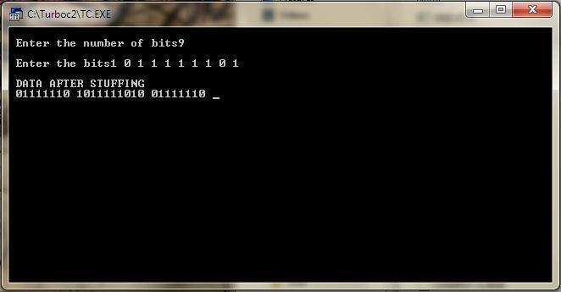

Objection 6 : Simple Tcp/Ip Client Server Communication Using C.

GIVEN REQUIREMENTS:

There are two hosts, Client and Server. The Client accepts the message from the user and sends it to the Server. The Server receives the message and prints it using c langauage.

TECHNICAL OBJECTIVE:

To implement a simple TCP Client-Server application, where the Client on establishing a connection with the Server, sends a string to the Server. The Server reads the String and prints it.

METHODOLOGY:
Server:

- Include the necessary header files.
- Create a socket using socket function with family AF_INET, type as SOCK_STREAM.
- Initialize server address to 0 using the bzero function.
- Assign the sin_family to AF_INET, sin_addr to INADDR_ANY, sin_port to a dynamically assigned port number.

- Bind the local host address to socket using the bind function.
- Listen on the socket for connection request from the client.
- Accept connection request from the client using accept function.
- Within an infinite loop, using the recv function receive message from the client and print it on the console.

Client:

- Include the necessary header files.

- Create a socket using socket function with family AF_INET, type as SOCK_STREAM.
- Initialize server address to 0 using the bzero function.
- Assign the sin_family to AF_INET.
- Get the server IP address and port number from the console.
- Using gethostbyname function assign it to a hostent structure, and assign it to sin_addr of the server address structure.
- Request a connection from the server using the connect function.
- Within an infinite loop, read message from the console and send the message to the server using the send function.

CODING:

AIM - Program for TCP Connection of Client and Server on Single System

Server Side
#include<sys/types.h>
#include<sys/socket.h>
#include<netinet/in.h>
#include<netdb.h>
#include<arpa/inet.h>
#include<string.h>
int main(int asrgc,char*argv[])

{
int bd,sd,ad; char buff[1024];
struct sockaddr_in cliaddr,servaddr; socklen_t clilen; clilen=sizeof(cliaddr); bzero(&servaddr,sizeof(servaddr));

/*Socket address structure*/ servaddr.sin_family=AF_INET; servaddr.sin_addr.s_addr=htonl(INADDR_ANY); servaddr.sin_port=htons(1999);

/*TCP socket is created, an Internet socket address structure is filled with wildcard address & server’s well known port*/

sd=socket(AF_INET,SOCK_STREAM,0);

/*Bind function assigns a local protocol address to the socket*/ bd=bind(sd,(struct sockaddr*)&servaddr,sizeof(servaddr));

/*Listen function specifies the maximum number of connections that kernel should queue for this socket*/

listen(sd,5);
printf("Server is running….\n");

/*The server to return the next completed connection from the front of the completed connection Queue calls it*/

ad=accept(sd,(struct sockaddr*)&cliaddr,&clilen); while(1)

{
bzero(&buff,sizeof(buff));

/*Receiving the request message from the client*/ recv(ad,buff,sizeof(buff),0);

printf("Message received is %s\n",buff);
}
}

Client Side

#include<stdio.h>
#include<string.h>
#include<sys/socket.h>
#include<sys/types.h>
#include<unistd.h>
#include<netinet/in.h>
#include<netdb.h>
#include<arpa/inet.h>
int main(int argc,char * argv[])
{
int cd,sd,ad; char buff[1024];

struct sockaddr_in cliaddr,servaddr;
struct hostent *h;

/*This function looks up a hostname and it returns a pointer to a hostent structure that contains all the IPV4 address*/
h=gethostbyname(argv[1]);
bzero(&servaddr,sizeof(servaddr));
/*Socket address structure*/ servaddr.sin_family=AF_INET;

memcpy((char *)&servaddr.sin_addr.s_addr,h->h_addr_list[0],h->h_length); servaddr.sin_port = htons(1999);

/*Creating a socket, assigning IP address and port number for that socket*/ sd = socket(AF_INET,SOCK_STREAM,0);

/*Connect establishes connection with the server using server IP address*/ cd=connect(sd,(struct sockaddr*)&servaddr,sizeof(servaddr));

while(1)
{ printf("Enter the message: \n");

/*Reads the message from standard input*/ fgets(buff,100,stdin);

/*Send function is used on client side to send data given by user on client side to the server*/

send(sd,buff,sizeof(buff)+1,0); printf("\n Data Sent "); //recv(sd,buff,strlen(buff)+1,0); printf("%s",buff);

}

}

EXPERMENT NO. 3

AIM - Program for TCP Connection of Client Server on two system

Server Side
import java.io.*;
import java.net.*;

public class MyServer1
{
ServerSocket ss;
Socket s;
DataInputStream dis;
DataOutputStream dos;
public MyServer1()
{
try
{
System.out.println("Server Started");
ss=new ServerSocket(10);
s=ss.accept();
System.out.println(s);
System.out.println("CLIENT CONNECTED");
dis= new DataInputStream(s.getInputStream());
dos= new DataOutputStream(s.getOutputStream());
ServerChat();
}
catch(Exception e)
{
System.out.println(e);
}
}

public static void main (String as[])
{
new MyServer1();
}

public void ServerChat() throws IOException
{
String str, s1;
do
{
str=dis.readUTF();
System.out.println("Client Message:"+str);
BufferedReader br=new BufferedReader(new InputStreamReader(System.in));
s1=br.readLine();
dos.writeUTF(s1);
dos.flush();
}
while(!s1.equals("bye"));
}
}

Client Side
import java.io.*;
import java.net.*;

public class MyClient1
{
Socket s;
DataInputStream din;
DataOutputStream dout;
public MyClient1()
{
try
{
//s=new Socket("10.10.0.3,10");
s=new Socket("localhost",10);
System.out.println(s);
din= new DataInputStream(s.getInputStream());
dout= new DataOutputStream(s.getOutputStream());
ClientChat();
}
catch(Exception e)
{
System.out.println(e);
}
}
public void ClientChat() throws IOException
{
BufferedReader br= new BufferedReader(new InputStreamReader(System.in));
String s1;
do
{
s1=br.readLine();
dout.writeUTF(s1);
dout.flush();
System.out.println("Server Message:"+din.readUTF());
}
while(!s1.equals("stop"));
}
public static void main(String as[])
{
new MyClient1();
}
}

EXPERIMENT NO. 4

AIM - Program for UDP Connection for Client Server on Single System

Server Side
#include<sys/socket.h>
#include<stdio.h>
#include<unistd.h>
#include<string.h>
#include<netinet/in.h>
#include<netdb.h>
#include<arpa/inet.h>

#include<sys/types.h>
int main(int argc,char *argv[])
{
int sd;
char buff[1024];
struct sockaddr_in cliaddr,servaddr; socklen_t clilen; clilen=sizeof(cliaddr);

/*UDP socket is created, an Internet socket address structure is filled with wildcard

address & server’s well known port*/
sd=socket(AF_INET,SOCK_DGRAM,0);
if (sd<0)
{
perror ("Cannot open Socket");
exit(1);
}
bzero(&servaddr,sizeof(servaddr));

/*Socket address structure*/

servaddr.sin_family=AF_INET;
servaddr.sin_addr.s_addr=htonl(INADDR_ANY);
servaddr.sin_port=htons(5669);

/*Bind function assigns a local protocol address to the socket*/

if(bind(sd,(struct sockaddr*)&servaddr,sizeof(servaddr))<0)
{
perror("error in binding the port");
exit(1);
}
printf("%s","Server is Running…\n");

while(1)

{
bzero(&buff,sizeof(buff));

/*Read the message from the client*/ if(recvfrom(sd,buff,sizeof(buff),0,(struct sockaddr*)&cliaddr,&clilen)<0)

{
perror("Cannot rec data"); exit(1);
}
printf("Message is received \n",buff);

/*Sendto function is used to echo the message from server to client side*/ if(sendto(sd,buff,sizeof(buff),0,(struct sockadddr*)&cliaddr,clilen)<0)

{
perror("Cannot send data to client"); exit(1);
}
printf("Send data to UDP Client: %s",buff);
}
close(sd); return 0;

}

Client Side
#include<sys/types.h>
#include<sys/socket.h>
#include<stdio.h>
#include<unistd.h>
#include<string.h>
#include<netinet/in.h>
#include<netdb.h>
int main(int argc,char*argv[])
{
int sd;
char buff[1024];
struct sockaddr_in servaddr; socklen_t len; len=sizeof(servaddr);

/*UDP socket is created, an Internet socket address structure is filled with wildcard address & server’s well known port*/

sd = socket(AF_INET,SOCK_DGRAM,0); if(sd<0)

{
perror("Cannot open socket"); exit(1);
}
bzero(&servaddr,len);

/*Socket address structure*/ servaddr.sin_family=AF_INET; servaddr.sin_addr.s_addr=htonl(INADDR_ANY); servaddr.sin_port=htons(5669);

while(1)
{
printf("Enter Input data : \n"); bzero(buff,sizeof(buff));

/*Reads the message from standard input*/ fgets(buff,sizeof (buff),stdin);

/*sendto is used to transmit the request message to the server*/ if(sendto (sd,buff,sizeof (buff),0,(struct sockaddr*)&servaddr,len)<0)
{

perror("Cannot send data"); exit(1);

}

printf("Data sent to UDP Server:%s",buff); bzero(buff,sizeof(buff));

/*Receiving the echoed message from server*/

if(recvfrom (sd,buff,sizeof(buff),0,(struct sockaddr*)&servaddr,&len)<0)
{
perror("Cannot receive data"); exit(1);
}
printf("Received Data from server: %s",buff);
}
close(sd); return 0;
}

EXPERIMENT NO. 5

AIM - Program for UDP Connection of Client Server on two system

Server Side
#include <sys/types.h>
#include <sys/socket.h>
#include <netinet/in.h>
#include <arpa/inet.h>
#include <stdio.h>
#include <unistd.h>
#include <errno.h>
#include <string.h>
#include <stdlib.h>

int main()
{
int sock;
int IPlength, TotalByte;
char message[512];
struct sockaddr_in serverAdd , clientAdd;
if ((sock = socket(AF_INET, SOCK_DGRAM, 0)) == -1)
{
perror("Socket Creation Failed");
exit(1);
}
serverAdd.sin_family = AF_INET;
serverAdd.sin_port = htons(5000);
serverAdd.sin_addr.s_addr = INADDR_ANY;
bzero(&(serverAdd.sin_zero),8);
if (bind(sock,(struct sockaddr *)&serverAdd,sizeof(struct sockaddr)) == -1)
{
perror("Bind Error");
exit(1);
}
IPlength = sizeof(struct sockaddr);
printf("\nUDP Server Waiting for client Message\n");
fflush(stdout);
while (1)
{
TotalByte = recvfrom(sock,message,512,0,(struct sockaddr *)&clientAdd, &IPlength);
message[TotalByte] = '\0';
printf("Received Message: %s", message);
fflush(stdout);
}
return 0;
}

Client Side
#include <sys/types.h>
#include <sys/socket.h>
#include <netinet/in.h>
#include <arpa/inet.h>
#include <netdb.h>
#include <stdio.h>
#include <unistd.h>
#include <errno.h>
#include <string.h>
#include <stdlib.h>

int main()
{
int sock;
struct sockaddr_in serverAdd;
struct hostent *host;
char sendMessage[512];
host= (struct hostent *) gethostbyname((char *)"Server’s IP address");
if ((sock = socket(AF_INET, SOCK_DGRAM, 0)) == -1)
{
perror("socket Creation Failed");
exit(1);
}
serverAdd.sin_family = AF_INET;
serverAdd.sin_port = htons(5000);
serverAdd.sin_addr = *((struct in_addr *)host->h_addr);
bzero(&(serverAdd.sin_zero),8);

while (1)
{
printf("Enter the Message:");
fgets(sendMessage,100,stdin);
sendto(sock, sendMessage, strlen(sendMessage), 0,(struct sockaddr *)&serverAdd, sizeof(struct sockaddr));
memset (sendMessage , 0 , sizeof(sendMessage));
}
}

AIM9:Repeat Exercise 7 with multiplexed I/O operations.

- So far, we have dealt with a single I/O channel
- We may need to cope with multiple I/O channels
e.g., supporting the echo service over multiple ports

- Problem: from which socket the server should accept connections or receive messages?
it can be solved using non-blocking sockets but it requires polling
- Solution: select()
specifies a list of descriptors to check for pending I/O operations
blocks until one of the descriptors is ready
returns which descriptors are ready
int select (maxDescPlus1, &readDescs, &writeDescs, &exceptionDescs, &timeout);
􀂉maxDescsPlus1: integer, hint of the maximum number of descriptors
􀂉readDescs: fd_set, checked for immediate input availability
􀂉writeDescs: fd_set, checked for the ability to immediately write data
􀂉exceptionDescs: fd_set, checked for pending exceptionstimeout: struct timeval, how long it blocks (NULL forever)
-returnsthe total number of ready descriptors,
-1 in case of error-changesthe descriptor lists so that only the corresponding positions are set

int FD_ZERO (fd_set*descriptorVector);/* removes all descriptors from vector*/
int FD_CLR (int descriptor, fd_set*descriptorVector);/*remove descriptor from vector */
int FD_SET (int descriptor, fd_set*descriptorVector);/*add descriptor to vector */
int FD_ISSET(int descriptor, fd_set*descriptorVector);/*vector membership check */

struct timeval{
time_ttv_sec;/* seconds */
time_ttv_usec;/* microseconds */
};

Multiplexing -Example: echo using stream socket
#include <sys/time.h> /* for struct timeval{} */
int main(intargc, char *argv[])
{
int *servSock; /* Socket descriptors for server */
int maxDescriptor; /* Maximum socket descriptor value */
fd_setsockSet; /* Set of socket descriptors for select() */
long timeout; /* Timeout value given on command-line */
struct timevalselTimeout; /* Timeout for select() */
int running = 1; /* 1 if server should be running; 0 otherwise */
int noPorts; /* Number of port specified on command-line */
int port; /* Looping variable for ports */
unsigned short portNo; /* Actual port number */
if (argc < 3) { /* Test for correct number of arguments */
fprintf(stderr, "Usage: %s <Timeout (secs.)> <Port 1> ...\n", argv[0]);
exit(1);
}
timeout= atol(argv[1]); /* First arg: Timeout */
noPorts= argc -2; /* Number of ports is argument count minus 2 */
servSock = (int *) malloc(noPorts* sizeof(int)); /* Allocate list of sockets for incoming connections */
maxDescriptor= -1; /* Initialize maxDescriptorfor use by select() */
for (port = 0; port < noPorts; port++) { /* Create list of ports and sockets to handle ports */
portNo= atoi(argv[port+ 2]); /* Add port to port list. Skip first two arguments */
servSock[port] = CreateTCPServerSocket(portNo); /* Create port socket */
if (servSock[port] > maxDescriptor)/* Determine if new descriptor is the largest */
maxDescriptor= servSock[port];
}

